**MICROCONTROLLERS PROJECT**

**THERMOSTAT CIRCUIT DESIGN**

Student: Uriciuc Mihai

Group: 2031 / Semigroup II

Table of Contents

1.Choosing the microcontroller 2

2. The LCD 4

# 1.Choosing the microcontroller

For this project is required to use a microcontroller from 8051 family. The **8051** is a family of **microcontrollers** originally developed by **Intel** in the 1980s. Think of it as a small computer you can program to control things — like lights, motors, sensors, or displays. With the help of the chosen microcontroller I will be able to read the temperature, to change the temperature in the room, to display various messages on a display or any other requirements that this whole project will have. So below I made a table with a few microcontrollers from this family to compare them and pick one suitable for my project.

|  |  |  |  |  |  |  |  |  |
| --- | --- | --- | --- | --- | --- | --- | --- | --- |
| **Microcontroller** | **Flash Memory** | **RAM** | **I/O Pins** | **ADC** | **UART** | **Speed (MHz)** | **Special Features** | **Price** |
| **AT89C51** | 4 KB | 128 B | 32 | no | yes | Up to 24 MHz | Basic, easy to use, beginner-friendly | ≈ 2.5$ |
| **AT89S52** | 8 KB | 256 B | 32 | no | yes | Up to 33 MHz | More flash, faster, better than AT89C51 | ≈ 10$ |
| **AT89C2051** | 2 KB | 128 B | 15 | no | yes | Up to 24 MHz | Tiny, good for small projects | ≈ 2$ |
| **P89V51RD2** | 64 KB | 1 KB | 32 | no | yes | Up to 40 MHz | Flash via USB, advanced and fast | ≈ 5$ |
| **AT89LP51RC2** | 8 KB | 256 B | 36 | no | yes | Up to 20 MHz | Low power, more I/Os, efficient | ≈ 4.26$ |

After comparing these microcontrollers, the one that suits my project the best is the first one, AT89C51, because it has flash memory more than enough for the code(Keil uVision admits only 2k of code), has enough speed, RAM and its cheap. Below I attached a screenshot from the datasheet of the microcontroller, and a picture of it in Proteus.

# 2. The LCD

The LCD that will be used for this project is LM016L. This one is an 16x2 (2 rows with 16 characters) alphanumeric LCD. Some key features of this LCD are the interface that works on both 4 bits and 8 bits, it has a port to control the contrast (port VEE) and it has an operating voltage of 5V.

|  |
| --- |
|  |

|  |  |  |  |  |
| --- | --- | --- | --- | --- |
|  | | | | |
| **Instruction** | **RS** | **R/W** | **D7** | **D6** | | **D5** | **D4** | **D3** | **D2** | **D1** | **D0** | **Hex Code** |
| 16x2 LCD Init | 0 | 0 | 0 | 0 | | 1 | 1 | 1 | 0 | 0 | 0 | 38h |
| Place Cursor | 0 | 0 | 0 | 0 | | 0 | 0 | 1 | 1 | 1 | 0 | 0Eh |
| Clear Display | 0 | 0 | 0 | 0 | | 0 | 0 | 0 | 0 | 0 | 1 | 01h |
| Write a Character | 1 | 0 | ASCII code for the character  (D0 = LSB, D7 = MSB) | | | | | | | | |  |
| Move Cursor to Line 2 | 0 | 0 | 1 | 1 | | 0 | 0 | 0 | 0 | 0 | 0 | C0h |
| Move Cursor to Line 1 | 0 | 0 | 1 | 0 | | 0 | 0 | 0 | 0 | 0 | 0 | 80h |
| Shift Cursor Left | 0 | 0 | 0 | 0 | | 0 | 0 | 1 | 0 | 0 | 0 | 10h |
| Cursor Off | 0 | 0 | 0 | 0 | | 0 | 0 | 0 | 1 | 1 | 0 | 0Ch |

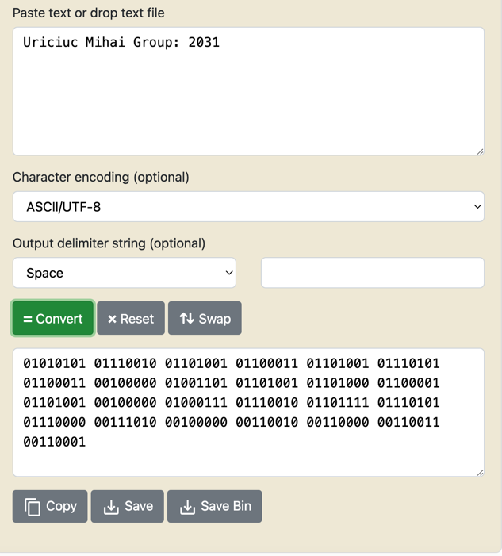

Using the Instructions above and having the message converted into ASCII I managed to display it on the LCD. For this to work we have to enter an instruction, switch Enable port to on then of, and after that the instruction should be visible on the display.